**Jhons Pizza Sale SQL Queries**

1. **KPI’s**
2. **Total Revenue**

select sum (total_price) as Total_Rrevenue from pizza_sales

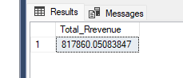

1. **Average Order Value**

select sum (total_price) / count(distinct order_id) as Avg_Order_value from pizza_sales

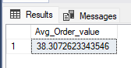

1. **Total Pizza Sold**

select sum(quantity) as Total_pizza from pizza_sales

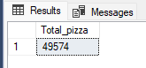

1. **Total Orders**

select count(distinct order_id) as Total_Orders from pizza_sales

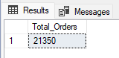

1. **Average Pizza Per Order**

select cast(cast(sum(quantity) as decimal(10,2)) / cast(count(distinct order_id) as decimal(10,2)) as decimal(10,2)) as Avg_Pizza_per_Order from pizza_sales

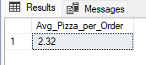

1. **Daily Trend for Total Orders**

select DATENAME(DW, order_date) as order_day, count(distinct order_id) as Total_Orders from pizza_sales group by DATENAME(DW,order_date)

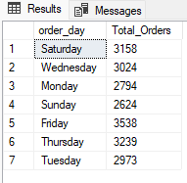

1. **Monthly Trend for Total Order**

select DATENAME(month, order_date) as Month_Name, count(distinct order_id) as Total_Orders from pizza_sales group by DATENAME(month, order_date) order by Total_Orders desc

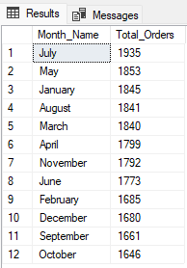 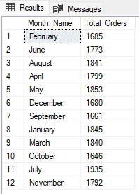

1. **Percentage of Sales by Pizza Category**

select pizza_category, sum(total_price) as Total_Sales, sum(total_price) * 100 / (select sum(total_price) from pizza_sales) as Percentage_of_Sales from pizza_sales group by pizza_category

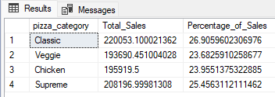

1. **Percentage of Sales by Pizza Size**

select pizza_size, cast(sum(total_price) as decimal(10,2)) as Total_Sales, cast(sum(total_price) * 100 / (select sum(total_price) from pizza_sales where DATEPART(quarter, order_date) = 1) as decimal(10,2)) as Percentage_of_Sales from pizza_sales where DATEPART(quarter, order_date) = 1 group by pizza_size order by Percentage_of_Sales desc

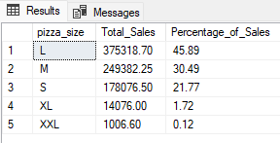 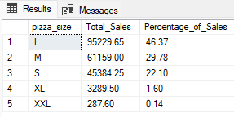

1. **Top 5 Best Selling Pizza and Revenue**

select top 5 pizza_name, sum(total_price) as Total_Revenue from pizza_sales group by pizza_name order by Total_Revenue desc

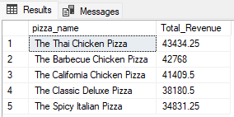

1. **Top 5 Bottom Selling Pizza and Revenue**

select top 5 pizza_name, sum(total_price) as Total_Revenue from pizza_sales group by pizza_name order by Total_Revenue asc

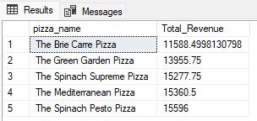

1. **Top 5 Best Selling Pizza by Total Quantity**

select top 5 pizza_name, sum(quantity) as Total_quantity from pizza_sales group by pizza_name order by Total_quantity desc

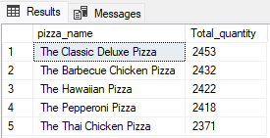

1. **Bottom 5 Selling Pizza by Total Quantity**

select top 5 pizza_name, sum(quantity) as Total_quantity from pizza_sales group by pizza_name order by Total_quantity asc

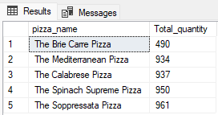

1. **Top 5 Best Selling Pizza by Total Orders**

select top 5 pizza_name, count(distinct order_id) as Total_Order from pizza_sales group by pizza_name order by Total_order desc

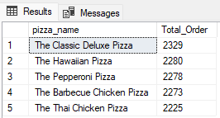

1. **Bottom 5 Selling Pizza by Total Orders**

select top 5 pizza_name, count(distinct order_id) as Total_Order from pizza_sales group by pizza_name order by Total_order asc

